

Travlr Getaways

# **CS 465 Project Software Design Document**

Version 1.0

## Table of Contents

**CS 465 Project Software Design Document** 1

Table of Contents 2

Document Revision History 2

Instructions 2

Executive Summary 3

Design Constraints 3

System Architecture View 3

Component Diagram 3

Sequence Diagram 4

Class Diagram 4

API Endpoints 4

The User Interface 4

## Document Revision History

| Version | Date | Author | Comments |
| --- | --- | --- | --- |
| 1.0 | <09/17/23> | <Dominic Aguirre> | <Brief description of changes in this revision> |

## Instructions

Fill in all bracketed information on page one (the cover page), in the Document Revision History table, and below each header. Under each header, remove the bracketed prompt and write your own paragraph response covering the indicated information.

## Executive Summary

The travlr is using the MEAN stack which consists of MongoDB, Express.JS, AngularJS, and Node.js to make a straightforward and easy to use website. This allows customers to search and book vacations with no extra hassle. For the property managers they’ll be able to have administrative access that allows them to change their listings as needed to suit them well.

## Design Constraints

Some of the biggest design constraints for the website include having to cater to different web browsers and platforms. With a public website you never know what someone will be accessing it from, could be a computer, a phone, or some other means and we want to make sure that the website works fluently on all the platforms. Along with that we want to make sure that the website is protected from users who might have bad intentions. We want to protect users data to make sure no one can access it other than those intended too.

## System Architecture View

### Component Diagram

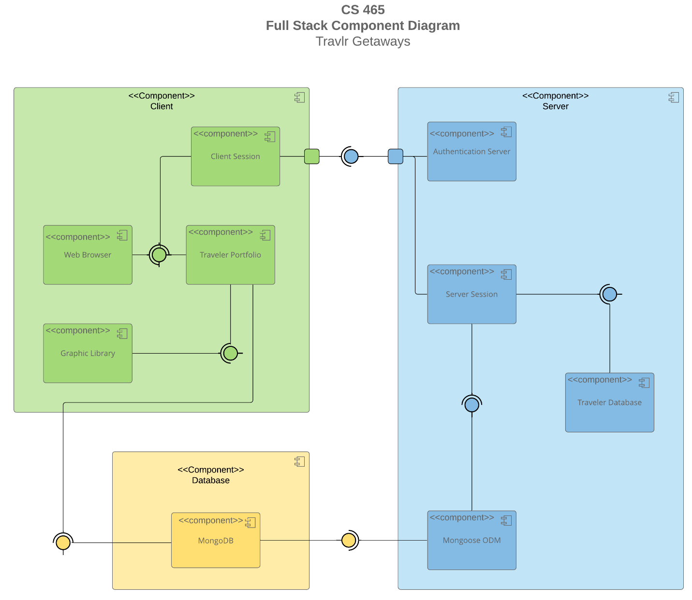

A text version of the component diagram is available: [CS 465 Full Stack Component Diagram Text Version](https://learn.snhu.edu/d2l/lor/viewer/view.d2l?ou=6606&loIdentId=24342).

In the diagram we can see the three core components of the website which include client side, server side, and the database. When the client accesses the website, they are given the client side of the application which takes the users inputs and displays the appropriate information from the database. The server side makes sure the correct connections are made to the database and other interfaces. The database holds all the information for the website and external API. All these parts are connected to make a smooth and seamless website.

### Sequence Diagram

<Illustrate the flow of logic in a web application by completing a sequence diagram. Insert an image of the sequence diagram here.>

<Describe the flow of logic in the web application based on the sequence diagram. Be sure to describe the interactions between the layers, or tiers, of the full stack application. It will be helpful to include significant processes such as Sign In, Trips, and Admin interactions when referring to the sequence diagram.>

## Class Diagram

<Illustrate the JavaScript classes of the web application by completing a class diagram for the web application. Insert an image of the class diagram here.>

<Describe the JavaScript classes of the web application based on the class diagram.>

## API Endpoints

<Exposing RESTful endpoints is a design approach to enable an application to participate in a larger ecosystem. Document each endpoint in the table below, including the HTTP method, purpose, URL, and notes.>

| **Method** | **Purpose** | **URL** | **Notes** |
| --- | --- | --- | --- |
| **GET** | <Retrieve list of things> | </api/things> | <Returns all active things> |
| **GET** | <Retrieve single thing> | </api/things/:thingId> | <Returns single thing instance, identified by the thing ID passed on the request URL> |

## The User Interface

<Insert screenshots from the development of the SPA development to show the following: (1) a unique trip, added by you, (2) the Edit screen, and (3) the Update screen.>

<Summarize the Angular project structure and how it compares to the Express project structure. Be sure to describe the rich functionality provided by the SPA compared to a simple web application interaction. Describe the process of testing to make sure the SPA is working with the API to GET and PUT data in the database.>